# NAME-ABHISHEK SAHIB; UID-23BCC70063; SUB- ADBMS

**EXP-12**

* **AIM:** To demonstrate deadlocks, MVCC, and transaction concurrency control in a student enrollment system.

# THEORY:

* Part A: Deadlocks in DBMS A deadlock occurs when two or more transactions wait indefinitely for resources locked by each other.
* Example:
* Transaction 1 locks row A and waits for row B.
* Transaction 2 locks row B and waits for row A.
* Most modern DBMS (MySQL InnoDB, PostgreSQL) detect deadlocks automatically and roll back one transaction to resolve it.
* Deadlocks can be avoided by consistent transaction ordering or using row-level locks carefully.
* Part B: MVCC (Multiversion Concurrency Control) MVCC allows readers and writers to work concurrently without blocking each other.
* Readers see a snapshot of data at the start of the transaction, unaffected by concurrent writes.
* Writers create a new version of the data; old versions remain visible to readers until their transactions commit.
* Part C: Comparing Locking vs MVCC Traditional Locking: Readers may block if a writer holds a lock (e.g., SELECT FOR UPDATE).
* MVCC: Readers see consistent snapshots; writers update without blocking readers.
* MVCC improves concurrency, performance, and user experience in high-concurrency environments.

# CODES:

* Part A: Simulating a deadlock

-- Drop table if exists

DROP TABLE IF EXISTS StudentEnrollments;

-- Create table

CREATE TABLE StudentEnrollments ( student_id INT PRIMARY KEY, student_name VARCHAR(100), course_id VARCHAR(10), enrollment_date DATE

);

-- Insert sample data

INSERT INTO StudentEnrollments VALUES (1, 'Ashish', 'CSE101', '2024-06-01'),

(2, 'Smaran', 'CSE102', '2024-06-01'),

(3, 'Vaibhav', 'CSE103', '2024-06-01');

Part B: Using MVCC for Non-Blocking R/W

-- Session 1 (User A) reads the record

## START TRANSACTION ISOLATION LEVEL REPEATABLE READ;

SELECT * FROM StudentEnrollments WHERE student_id

= 1;

-- Output: enrollment_date = 2024-06-01

-- This snapshot is maintained even if other transactions update

-- Session 2 (User B) updates the same record concurrently START TRANSACTION;

UPDATE StudentEnrollments

SET enrollment_date = '2024-07-10' WHERE student_id = 1;

## COMMIT;

-- Session 1 still sees enrollment_date = 2024-06-01

-- Until User A commits or restarts the transaction COMMIT;

-- Session 1 sees the updated value after commit

SELECT * FROM StudentEnrollments WHERE student_id

= 1;

-- Output: enrollment_date = 2024-07-10

* + Part C: Comparing Locking vs MVC
  + Without MVCC

-- Session 1

## START TRANSACTION;

SELECT * FROM StudentEnrollments WHERE student_id

## = 1 FOR UPDATE;

-- Session 2 tries

UPDATE StudentEnrollments SET enrollment_date = '2024-08-01' WHERE student_id = 1;

-- Session 2 is blocked until Session 1 commits

* + With MVCC

-- Session 1

## START TRANSACTION ISOLATION LEVEL REPEATABLE READ;

SELECT * FROM StudentEnrollments WHERE student_id

= 1;

-- Session 2 updates concurrently

UPDATE StudentEnrollments SET enrollment_date = '2024-09-01' WHERE student_id = 1;

## COMMIT;

-- Session 1 still sees old value (2024-07-10) until commit COMMIT;

# OUTPUTS:

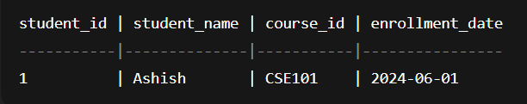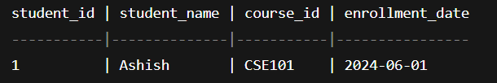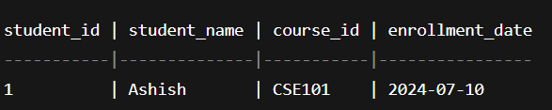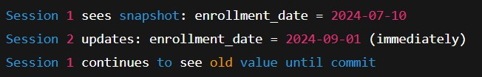

* **LEARNING OUTCOMES:**

1. Learned to enforce unique constraints to prevent duplicate student enrollments.
2. Understood row-level locking using SELECT FOR UPDATE to handle concurrent transactions.
3. Observed how transactions preserve Atomicity and Consistency in a multi-user environment.
4. Practiced handling blocked transactions and understanding isolation effects.
5. Gained hands-on experience with ACID principles in a practical enrollment scenario.